Test Case: tc002_SPX_Dev5_Crear_Requisicion_Spot_Con_FAD_Tipo_Cobro_CC
Step 1 - Enter username and password and click to button Enter : Credentials Entered
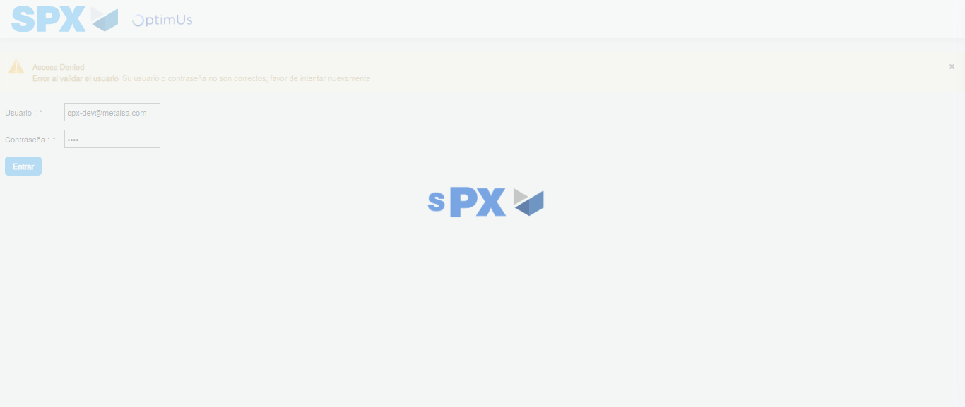Image file-name: QC_Testing-tc002_SPX_Dev5_Crear_Requisicion_Spot_Con_FAD_Tipo_Cobro_CC-1783355873492

Step 2 - Select to UEN and Access to Spot Buy Requisitions : UEN Correctly selected and Correct access
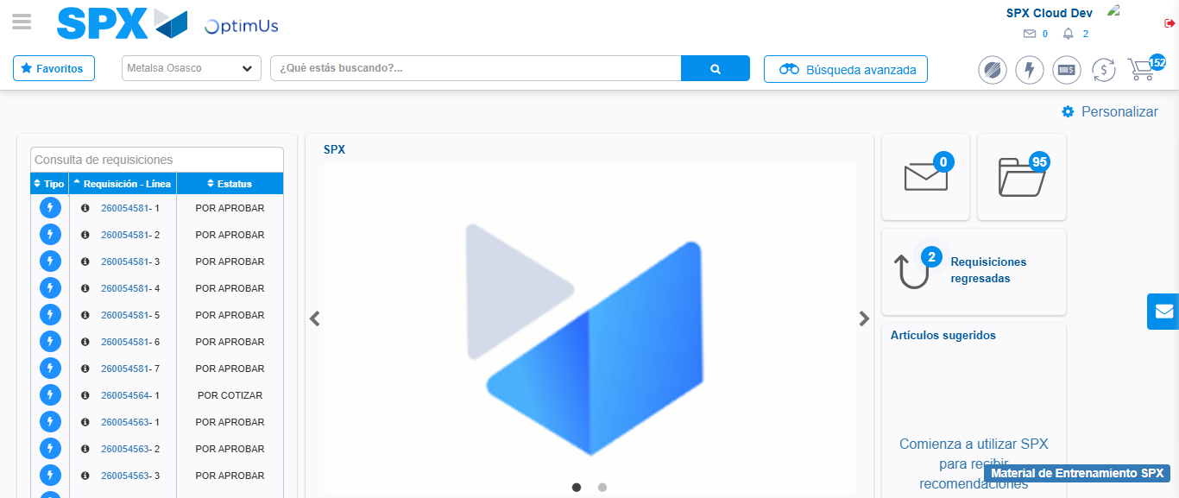Image file-name: QC_Testing-tc002_SPX_Dev5_Crear_Requisicion_Spot_Con_FAD_Tipo_Cobro_CC-1783355898567

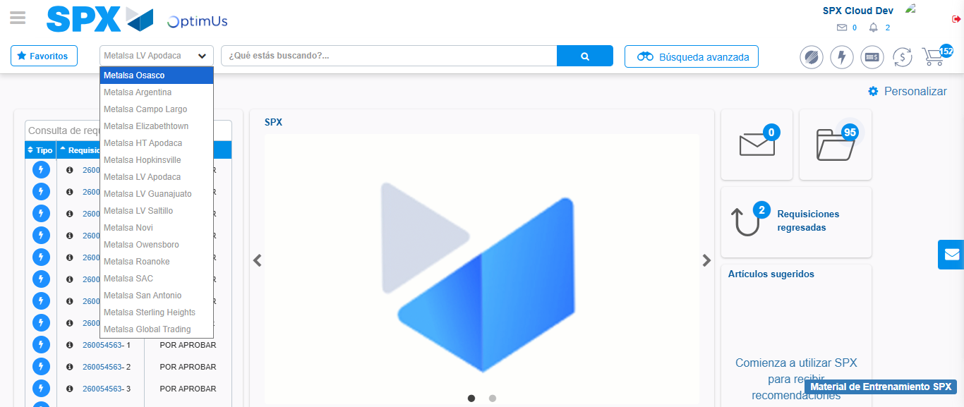Image file-name: QC_Testing-tc002_SPX_Dev5_Crear_Requisicion_Spot_Con_FAD_Tipo_Cobro_CC-1783355901133

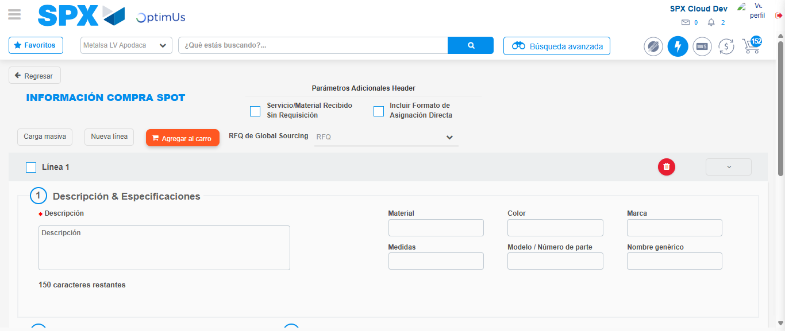Image file-name: QC_Testing-tc002_SPX_Dev5_Crear_Requisicion_Spot_Con_FAD_Tipo_Cobro_CC-1783355921748

Step 3 - Add FAD to Requisition: FAD Successfully Added
Image file-name: QC_Testing-tc002_SPX_Dev5_Crear_Requisicion_Spot_Con_FAD_Tipo_Cobro_CC-1783355921979

Image file-name: QC_Testing-tc002_SPX_Dev5_Crear_Requisicion_Spot_Con_FAD_Tipo_Cobro_CC-1783355922209

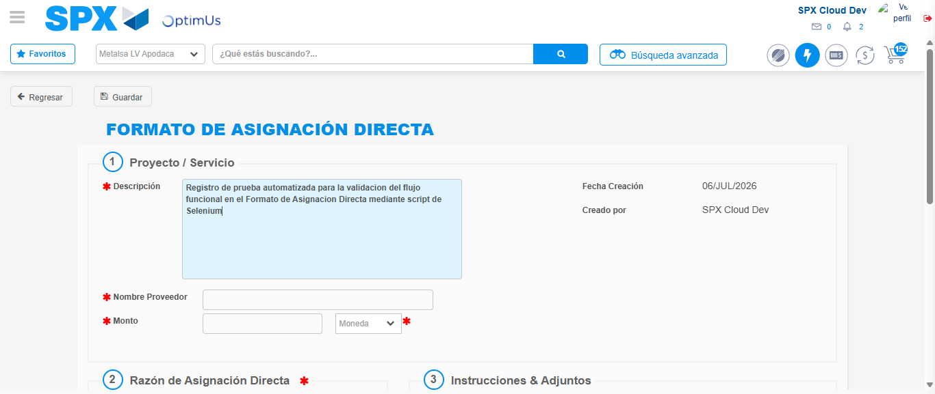Image file-name: QC_Testing-tc002_SPX_Dev5_Crear_Requisicion_Spot_Con_FAD_Tipo_Cobro_CC-1783355924946

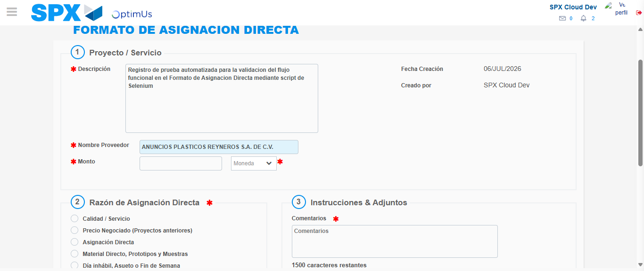Image file-name: QC_Testing-tc002_SPX_Dev5_Crear_Requisicion_Spot_Con_FAD_Tipo_Cobro_CC-1783355930853

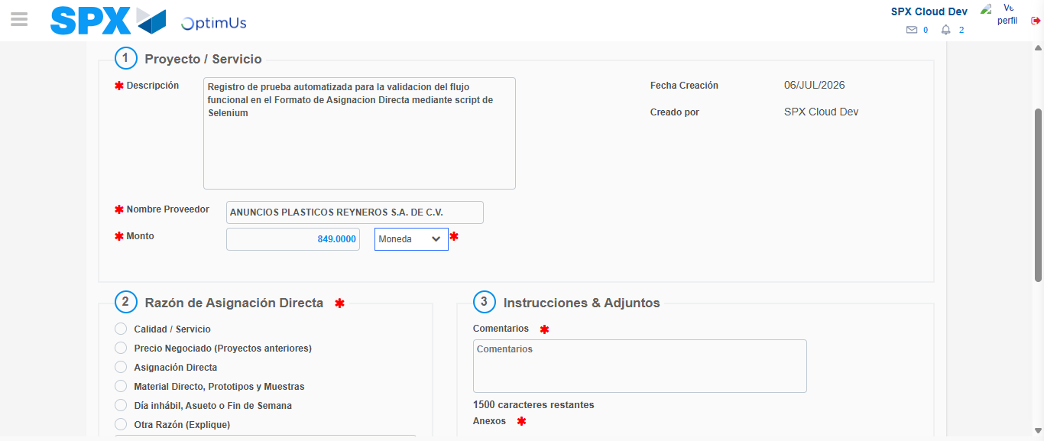Image file-name: QC_Testing-tc002_SPX_Dev5_Crear_Requisicion_Spot_Con_FAD_Tipo_Cobro_CC-1783355931242

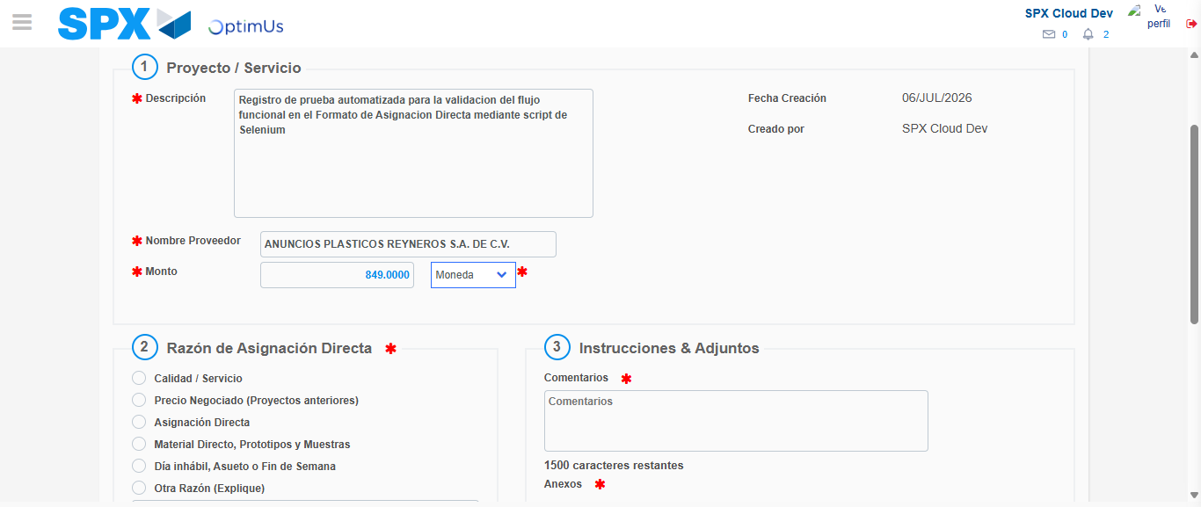Image file-name: QC_Testing-tc002_SPX_Dev5_Crear_Requisicion_Spot_Con_FAD_Tipo_Cobro_CC-1783355931457

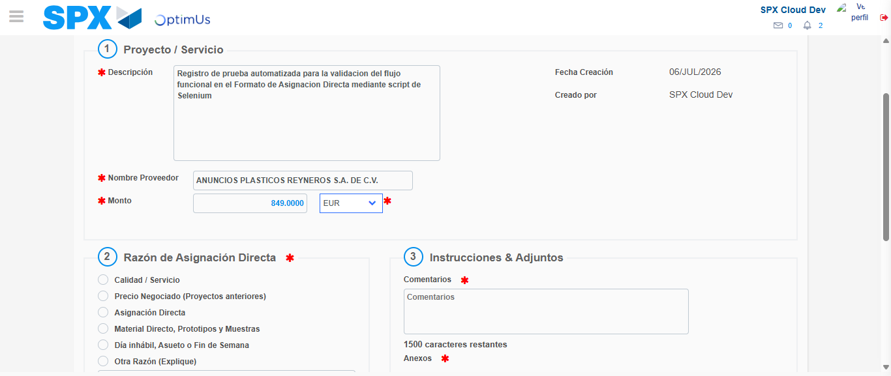Image file-name: QC_Testing-tc002_SPX_Dev5_Crear_Requisicion_Spot_Con_FAD_Tipo_Cobro_CC-1783355931853

Image file-name: QC_Testing-tc002_SPX_Dev5_Crear_Requisicion_Spot_Con_FAD_Tipo_Cobro_CC-1783355932018

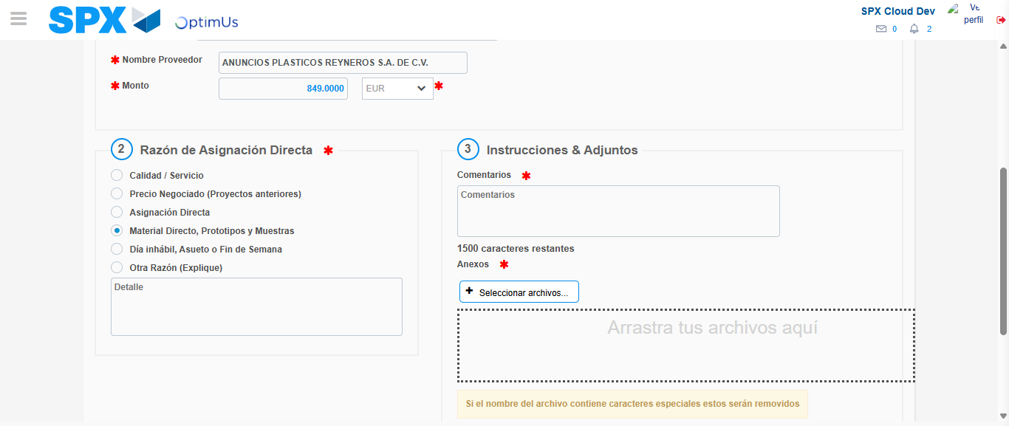Image file-name: QC_Testing-tc002_SPX_Dev5_Crear_Requisicion_Spot_Con_FAD_Tipo_Cobro_CC-1783355932876

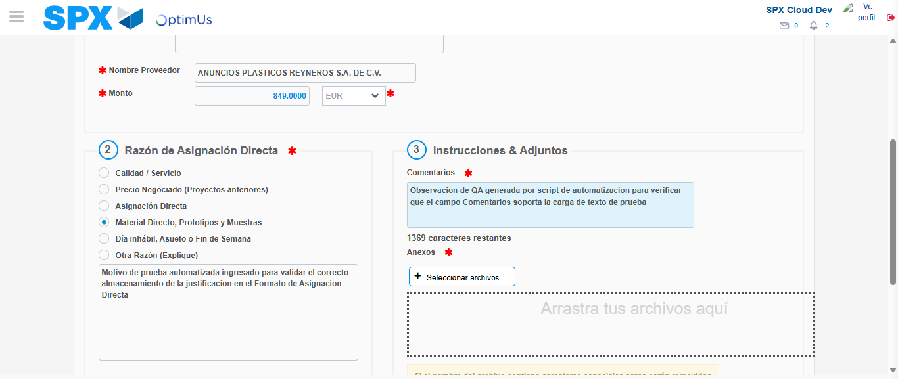Image file-name: QC_Testing-tc002_SPX_Dev5_Crear_Requisicion_Spot_Con_FAD_Tipo_Cobro_CC-1783355943902

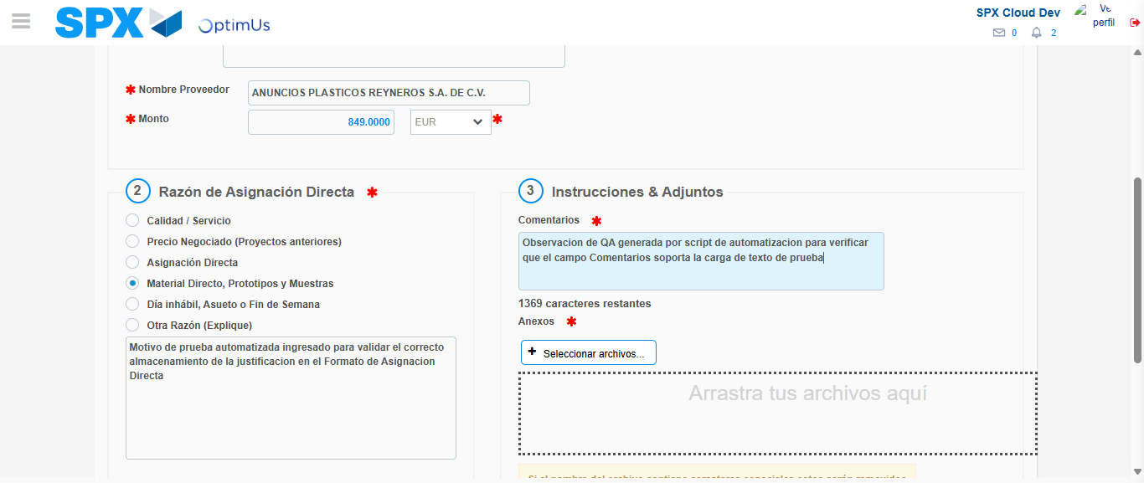Image file-name: QC_Testing-tc002_SPX_Dev5_Crear_Requisicion_Spot_Con_FAD_Tipo_Cobro_CC-1783355944474

Step 4 - Data Capture Spot Buy Requisition: Data captured correctly
Image file-name: QC_Testing-tc002_SPX_Dev5_Crear_Requisicion_Spot_Con_FAD_Tipo_Cobro_CC-1783355921979

Image file-name: QC_Testing-tc002_SPX_Dev5_Crear_Requisicion_Spot_Con_FAD_Tipo_Cobro_CC-1783355922209

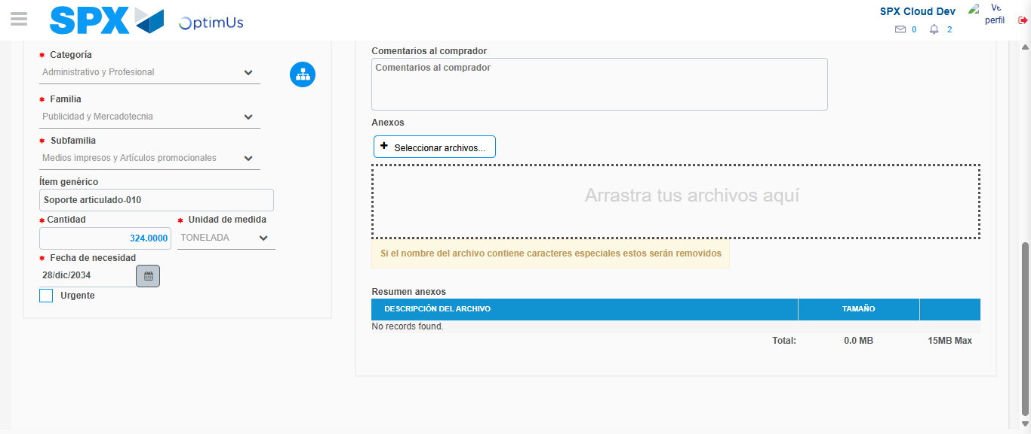Image file-name: QC_Testing-tc002_SPX_Dev5_Crear_Requisicion_Spot_Con_FAD_Tipo_Cobro_CC-1783355957060

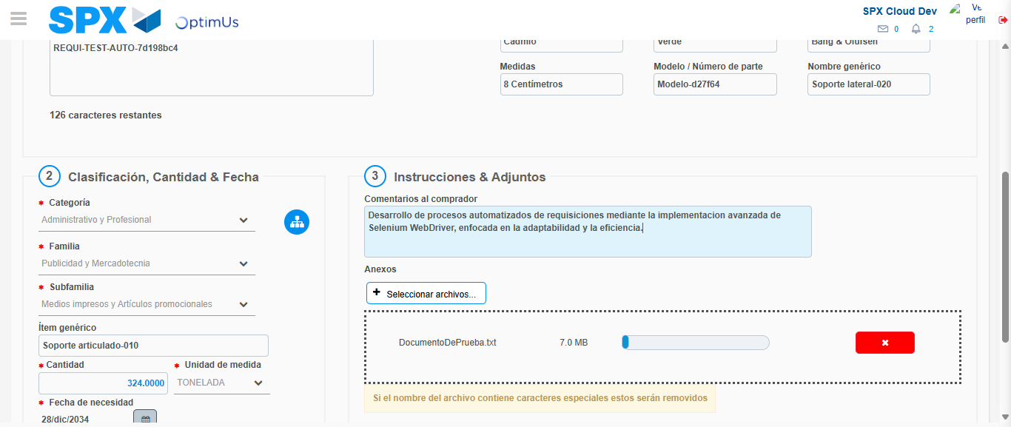Image file-name: QC_Testing-tc002_SPX_Dev5_Crear_Requisicion_Spot_Con_FAD_Tipo_Cobro_CC-1783355957972

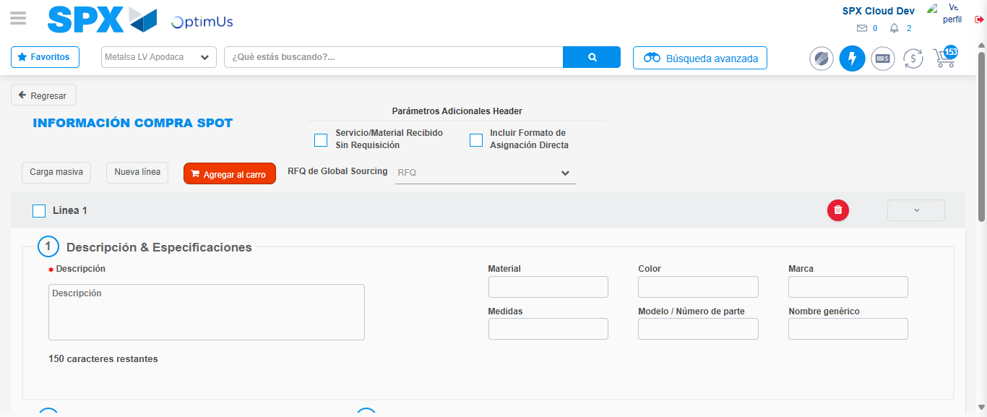Image file-name: QC_Testing-tc002_SPX_Dev5_Crear_Requisicion_Spot_Con_FAD_Tipo_Cobro_CC-1783355965934

Step 8 - Return to Main Page SPX : Return to Main Page SPX
Image file-name: QC_Testing-tc002_SPX_Dev5_Crear_Requisicion_Spot_Con_FAD_Tipo_Cobro_CC-1783355898567

Image file-name: QC_Testing-tc002_SPX_Dev5_Crear_Requisicion_Spot_Con_FAD_Tipo_Cobro_CC-1783355901133

Image file-name: QC_Testing-tc002_SPX_Dev5_Crear_Requisicion_Spot_Con_FAD_Tipo_Cobro_CC-1783355921748

Image file-name: QC_Testing-tc002_SPX_Dev5_Crear_Requisicion_Spot_Con_FAD_Tipo_Cobro_CC-1783355968280

Image file-name: QC_Testing-tc002_SPX_Dev5_Crear_Requisicion_Spot_Con_FAD_Tipo_Cobro_CC-1783355968489

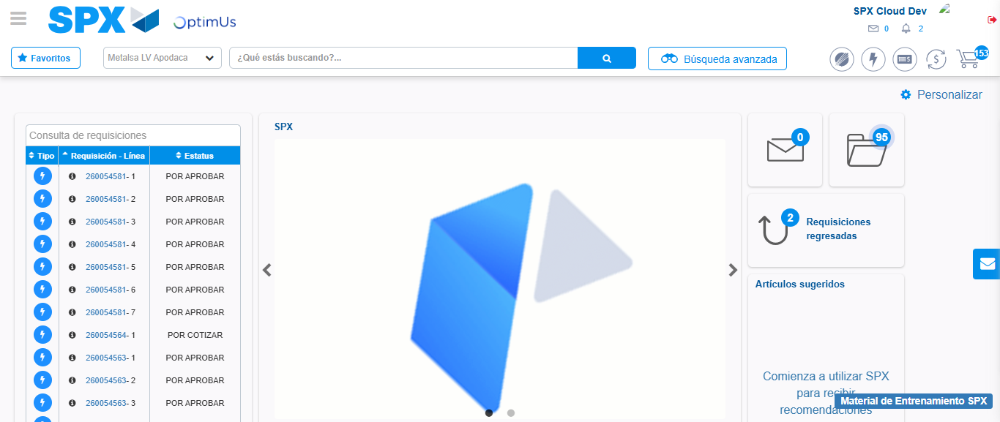Image file-name: QC_Testing-tc002_SPX_Dev5_Crear_Requisicion_Spot_Con_FAD_Tipo_Cobro_CC-1783355989815

Step 9 - Log Out : Log Out SPX
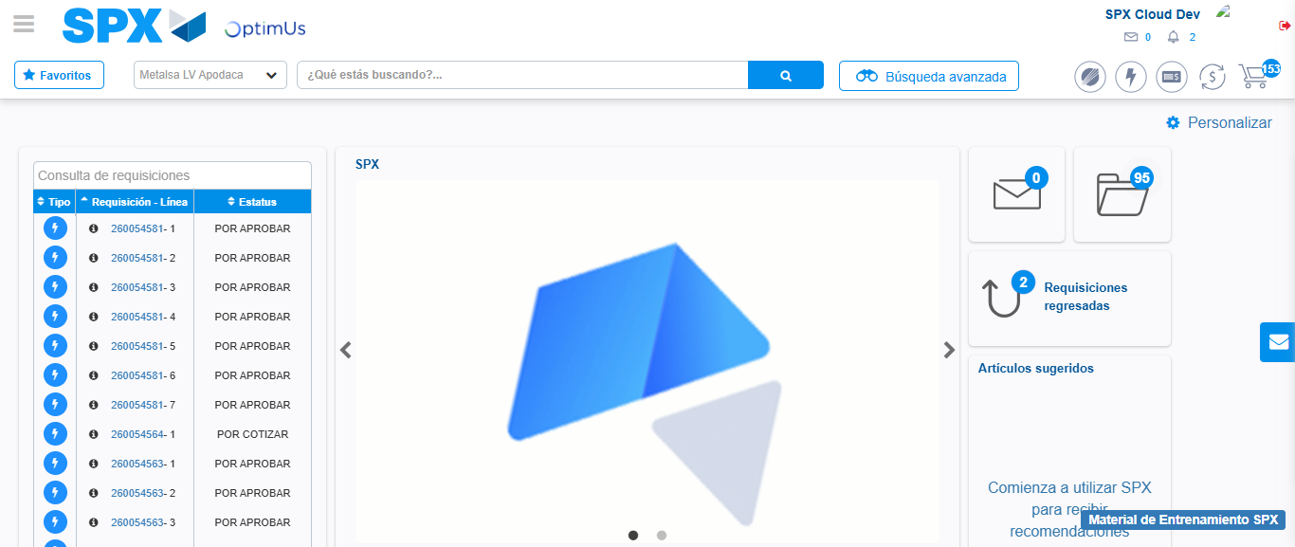Image file-name: QC_Testing-tc002_SPX_Dev5_Crear_Requisicion_Spot_Con_FAD_Tipo_Cobro_CC-1783355990180

